Please find see the screenshot & payloads given below;

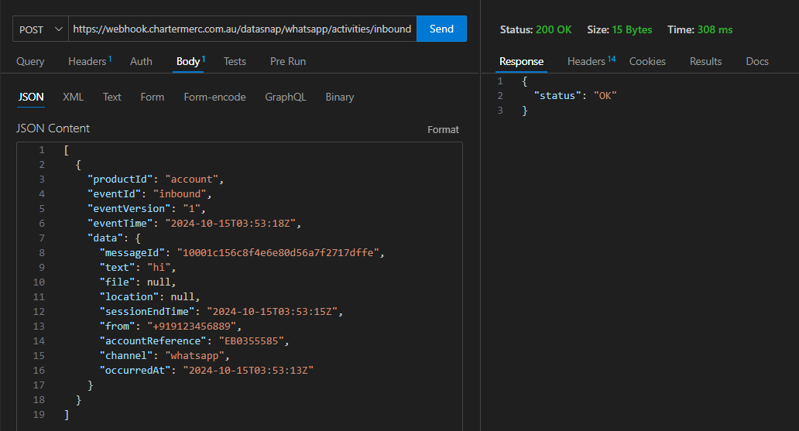

**API Payload:**

**1.**

*curl -X POST *

*'https://webhook.chartermerc.com.au/datasnap/whatsapp/activities/inbound' *

*--header 'Accept: application/json' *

*--header 'Content-Type: application/json' *

*--data-raw '[*

*{*

*"productId": "account",*

*"eventId": "inbound",*

*"eventVersion": "1",*

*"eventTime": "2024-10-15T03:53:18Z",*

*"data": {*

*"messageId": "10001c156c8f4e6e80d56a7f2717dffe",*

*"text": "hi",*

*"file": null,*

*"location": null,*

*"sessionEndTime": "2024-10-15T03:53:15Z",*

*"from": "+919123456889",*

*"accountReference": "EB0355585",*

*"channel": "whatsapp",*

*"occurredAt": "2024-10-15T03:53:13Z"*

*}*

*}*

*]'*

2.

curl -X POST \

'https://webhook.chartermerc.com.au/datasnap/whatsapp/activities/read' \

--header 'Accept: application/json' \

--header 'Content-Type: application/json' \

--data-raw '[

{

"productId": "richcontentapi",

"eventId": "read",

"eventVersion": "1",

"eventTime": "2024-10-15T03:52:40Z",

"data": {

"gatewayId": "10009a26-a872-4593-b3da-c5be9fe19209",

"messageId": "20009dd5-8ff2-4c65-8915-097cb7a5a221",

"metadata": {

"uniqueid": "100"

},

"recipient": {

"address": {

"msisdn": "+919123456889"

}

},

"accountReference": "EB0355585",

"channel": "whatsapp",

"occurredAt": "2024-10-25T03:52:38Z"

}

}

]'

3.

curl -X POST \

'https://webhook.chartermerc.com.au/datasnap/whatsapp/activities/stop' \

--header 'Accept: application/json' \

--header 'Content-Type: application/json' \

--data-raw '[

{

"productId": "richcontentapi",

"eventId": "stop",

"eventVersion": "1",

"eventTime": "2024-10-15T03:52:40Z",

"data": {

"gatewayId": "10009a26-a872-4593-b3da-c5be9fe19209",

"messageId": "20009dd5-8ff2-4c65-8915-097cb7a5a221",

"metadata": {

"uniqueid": "100"

},

"recipient": {

"address": {

"msisdn": "+919123456889"

}

},

"accountReference": "EB0355585",

"channel": "whatsapp",

"occurredAt": "2024-10-25T03:52:38Z"

}

}

]'

4.

curl -X POST \

'https://webhook.chartermerc.com.au/datasnap/whatsapp/activities/clicked' \

--header 'Accept: application/json' \

--header 'Content-Type: application/json' \

--data-raw '[

{

"productId": "richcontentapi",

"eventId": "clicked",

"eventVersion": "1",

"eventTime": "2024-10-15T03:52:40Z",

"data": {

"gatewayId": "10009a26-a872-4593-b3da-c5be9fe19209",

"messageId": "20009dd5-8ff2-4c65-8915-097cb7a5a221",

"metadata": {

"uniqueid": "100"

},

"recipient": {

"address": {

"msisdn": "+919123456889"

}

},

"accountReference": "EB0355585",

"channel": "whatsapp",

"occurredAt": "2024-10-25T03:52:38Z"

}

}

]'

5.

curl -X POST \

'https://webhook.chartermerc.com.au/datasnap/whatsapp/activities/delivered' \

--header 'Accept: application/json' \

--header 'Content-Type: application/json' \

--data-raw '[

{

"productId": "richcontentapi",

"eventId": "delivered",

"eventVersion": "1",

"eventTime": "2024-10-15T03:52:40Z",

"data": {

"gatewayId": "10009a26-a872-4593-b3da-c5be9fe19209",

"messageId": "20009dd5-8ff2-4c65-8915-097cb7a5a221",

"metadata": {

"uniqueid": "100"

},

"recipient": {

"address": {

"msisdn": "+919123456889"

}

},

"accountReference": "EB0355585",

"channel": "whatsapp",

"occurredAt": "2024-10-25T03:52:38Z"

}

}

]'

6.

curl -X POST \

'https://webhook.chartermerc.com.au/datasnap/whatsapp/activities/failed' \

--header 'Accept: application/json' \

--header 'Content-Type: application/json' \

--data-raw '[

{

"productId": "richcontentapi",

"eventId": "failed",

"eventVersion": "1",

"eventTime": "2024-10-15T03:52:40Z",

"data": {

"gatewayId": "10009a26-a872-4593-b3da-c5be9fe19209",

"messageId": "20009dd5-8ff2-4c65-8915-097cb7a5a221",

"metadata": {

"uniqueid": "100"

},

"recipient": {

"address": {

"msisdn": "+919123456889"

}

},

"accountReference": "EB0355585",

"channel": "whatsapp",

"occurredAt": "2024-10-25T03:52:38Z"

}

}

]'